b-plus launches groundbreaking b-ISOBUS AUX-N gaming controller unit
Revolutionary enhancement to b-ISOBUS AUX-N gateway
Deggendorf, 2024/04/01 – b-plus, experts in mobile automation, have announced a revolutionary enhancement to their b-ISOBUS AUX-N gateway - an operating unit that brings the functionality of a gaming controller to agriculture. This step marks an unprecedented advance in the combination of precision agricultural technology and interactive entertainment.
The new control unit enables farmers to experience the operation of their agricultural equipment in a new way and switch seamlessly between virtual and real farming: The b-ISOBUS AUX-N gateway, an established product from b-plus, now offers the option of using a gaming controller interface. This allows modern farmers to transfer the familiar intuitiveness and ergonomics of gaming controllers and consoles to everyday work in the field.
The b-plus team has developed a solution that is not only innovative from a technical point of view, but also facilitates and enriches the everyday work of farmers. The gaming controller operating unit can be connected to the ISOBUS InCab socket without tools and within seconds. The buttons on the gaming controller can be programmed directly on the Virtual Terminal in the cab to control the functions on the implement.

The potential impact on efficiency and user experience in agriculture could be enormous by combining work in the field with the entertainment and convenience of a gaming controller.

The new feature will be available from April 1, 2024. For more information about the b-ISOBUS AUX-N gaming controller unit and other innovations from b-plus, please contact us.

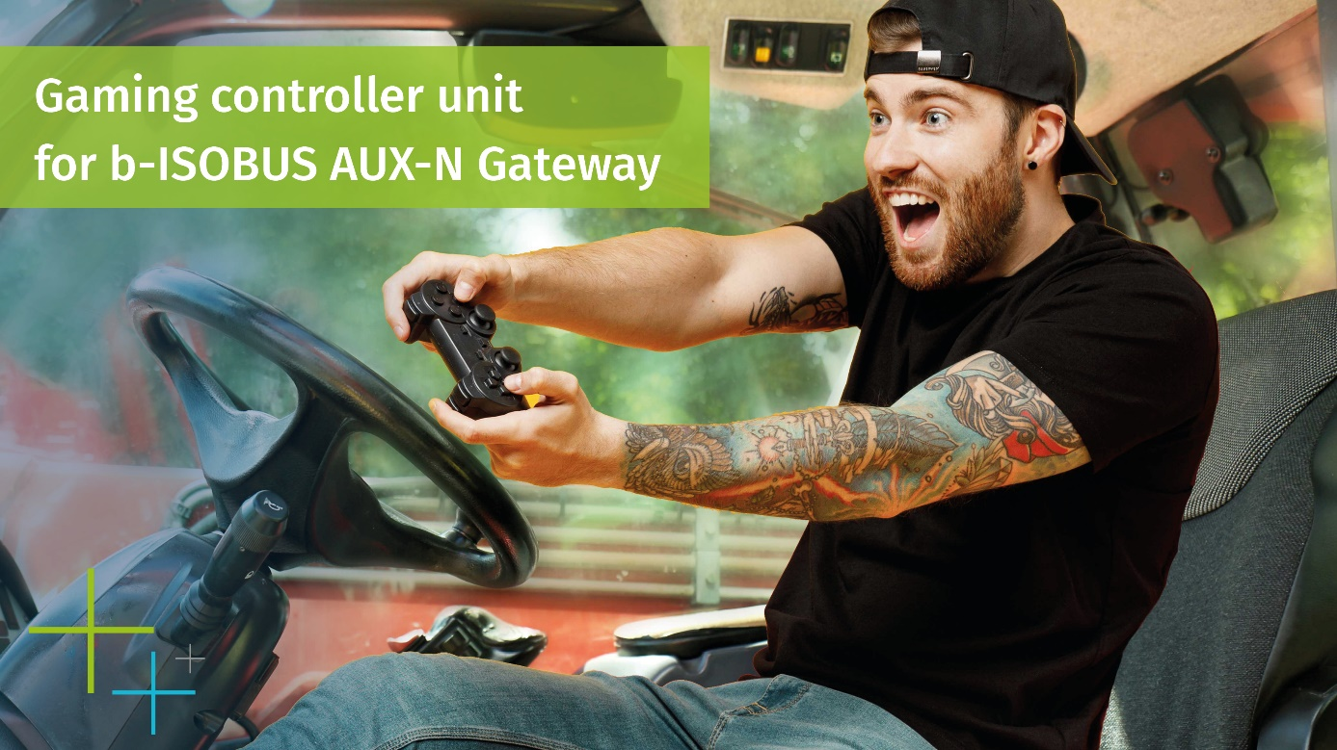
Picture: Gaming controller unit for b-ISOBUS AUX-N Gateway
ANSPRECHPARTNER

Simone Adam
Marketing Communication
simone.adam@b-plus.com

Sabine Igl
Product Marketing
sabine.igl@b-plus.com

Phone: +49 991 270302-0
b-plus.com

Address:
b-plus automotive GmbH
Ulrichsberger Str. 17
94469 Deggendorf
Germany

ABOUT B-PLUS GROUP
The b-plus Group employs around 240 people. It is an internationally networked development partner for the advancement of autonomous driving technologies, driver assistance systems and the automation of mobile machines. With its development tools, automotive software and mobile automation divisions, it offers its customers a wide range of measurement technology, software and hardware.

As a long-term partner, b-plus accompanies its customers from the identification of the problem to the implementation of the development solution and beyond. The teams at the Deggendorf, Regensburg, Cham and Lindau sites work closely together and hand in hand to offer comprehensive and holistic solutions.

