b-plus strengthens presence in Europe
Expansion of sales team and collaborations strengthen market position

Deggendorf, November 23, 2023 – b-plus is intensifying its commitment to Mobile Automation in Northern Germany, Scandinavia and Poland. Through the expansion of its sales team, a strategic partnership with the system integrator Thorsen-Teknik as well as a distribution partnership with ARETE, the company is further expanding its local presence to better serve the needs of customers in the region.

In the area of Mobile Automation, b-plus is dedicated to its pursuit of growth and is expanding its activities. Since September, Sebastian Spiegel has joined the sales team, bringing extensive knowledge of agricultural technology as a Master Agricultural Machinery Technician. He will be responsible for serving customers and prospects in the Northern sales region. Before joining b-plus, Sebastian gained valuable experience at a renowned manufacturer of agricultural machinery and an expert in Precision Farming. His market insights and commitment to customer satisfaction will undoubtedly contribute to the advancement and expansion of customer support in Northern Germany.

In the Scandinavian region, b-plus has formed a partnership with the system integrator Thorsen-Teknik. This collaboration allows b-plus to profit from the expertise and local resources of Thorsen-Teknik to offer innovative solutions to customers in Denmark and other Scandinavian countries.
Torben Thorsen, CEO and owner of Thorsen-Teknik, says: "We are happy to work with b-plus. This partnership opens up even more opportunities for our customers. Strong relationships and collaborations like this help us to continuously strengthen our position as a leader in retrofitting precision solutions for agriculture. We look forward to creating groundbreaking projects together.

In Poland, b-plus relies on its partnership with the system integrator ARETE, a provider of machine control systems. ARETE supplies its customers with high-quality control panels and controllers. As distributor of b-plus, the company provides access to the latest technologies on the Polish market. “We are exceptionally delighted to have the opportunity to market the products of b-plus in Poland", remarks Czeslaw Klejbuk, CEO of ARETE.

"We are very excited to strengthen our presence in Europe" says Harald Bügel, CEO of b-plus mobile control. "With Sebastian Spiegel in the sales team, Thorsen-Teknik as a system integrator for Scandinavia and ARETE for Poland, we are well-positioned to offer our solutions with expertise and region-specific knowledge, meeting the needs of our customers even more effectively. We look forward to continued collaboration."

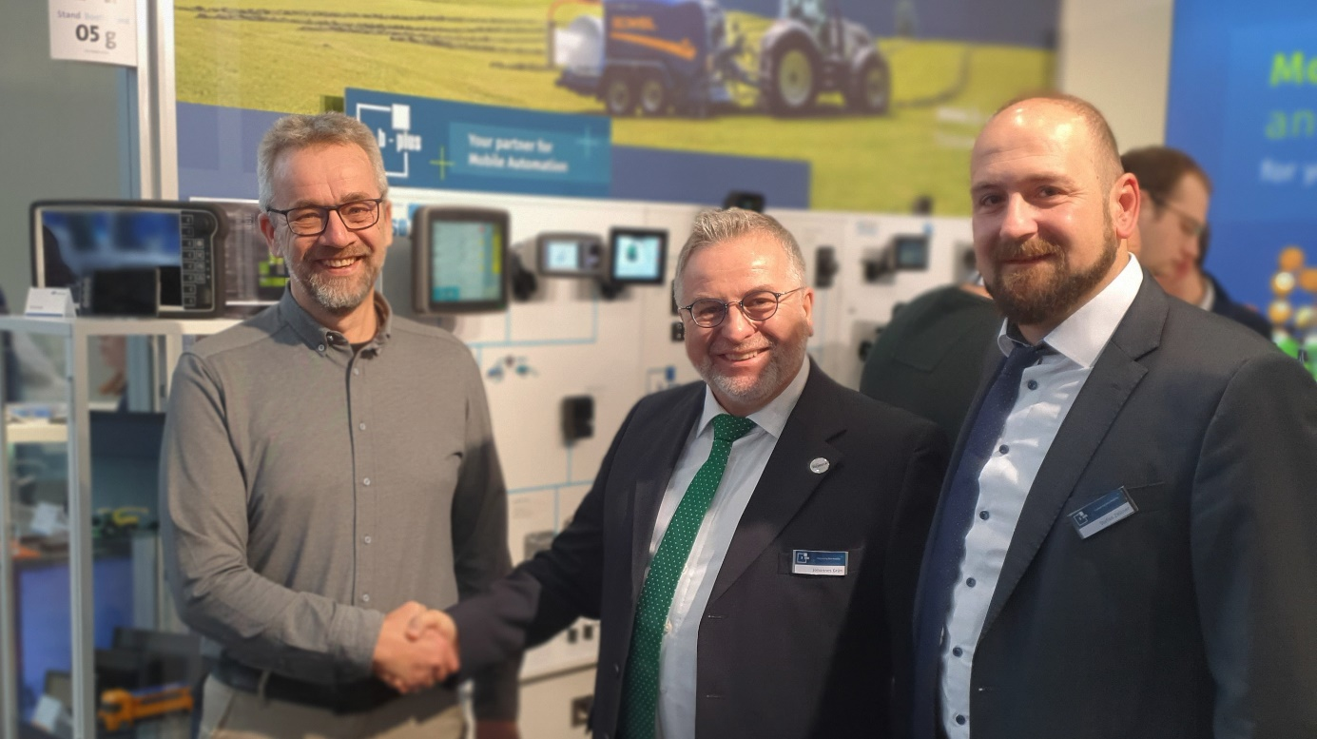
The collaboration between b-plus and Thorsen Teknik was symbolically sealed with a handshake at Agritechnica in Hannover. From left to right: Torben Thorsen (CEO Thorsen-Teknik), Johannes Grün (b-plus Teamleader sales) and Stefan Zellner (b-plus product management)

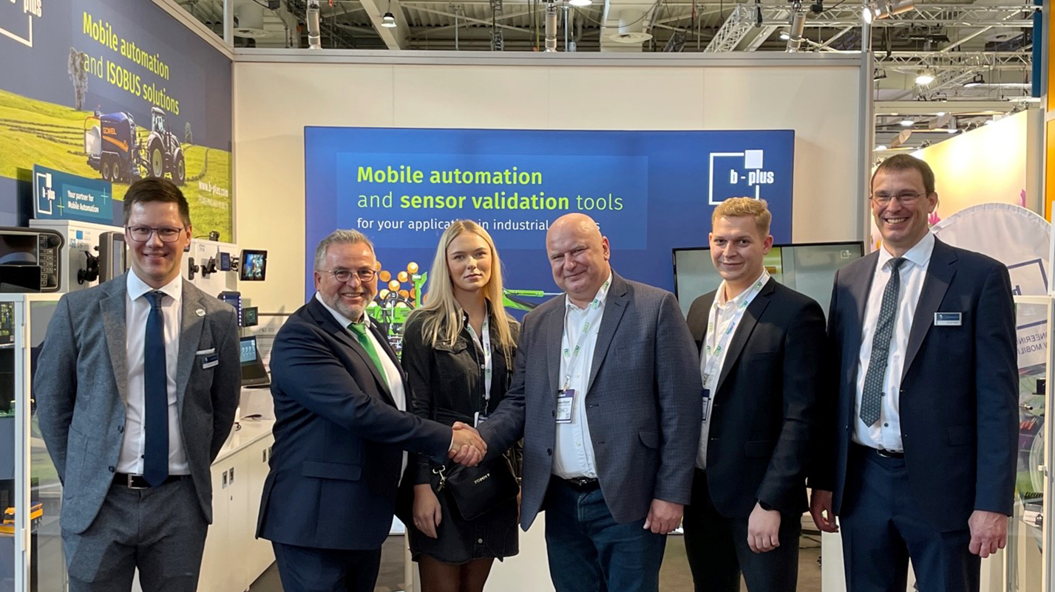
Also the partners from ARETE came to visit at Agritechnica. From left to right: Sebastian Spiegel (b-plus sales), Johannes Grün (b-plus Teamleader sales), Klaudia Bielawska (Marketing ARETE), Czeslaw Klejbuk (managing director ARETE), Marek Margielewicz (Shareholder ARETE) and Harald Bügel (managing director b-plus mobile control)

CONTACT

Sabine Igl
Product Marketing
sabine.igl @b-plus.com

Simone Adam
Marketing Communications
simone.adam@b-plus.com

phone: +49 991 270302-0
www.b-plus.com

Address:
b-plus mobile control GmbH
Ulrichsberger Str. 17
94469 Deggendorf
Germany

ABOUT B-PLUS MOBILE CONTROL
In the field of Mobile Automation, b-plus offers a wide spectrum of services, including engineering, programming, and the distribution of components for the electrification of off-highway applications, such as mobile machinery, construction equipment, agricultural machinery, and special vehicle construction. b-plus is known for its decades of experience in CAN bus and ISOBUS technologies, Ethernet/WLAN, BroadR-Reach®, programming in C, C++, Qt, and CODESYS®, as well as Functional Safety

ABOUT THORSEN-TEKNIK
Thorsen-Teknik is a leading player in precision solutions for agriculture, with its own software department. With expertise in retrofitting precision equipment and advanced software solutions, Thorsen-Teknik has established itself as a reliable partner that tailors intelligent and user-friendly solutions for agriculture. Their software competencies include advanced control systems, precision farming and data-driven solutions that optimize efficiency and sustainability in the agricultural sector.

ABOUT ARETE
ARETE Klejbuk Spółka Jawna is a dynamically growing provider of machine control systems. The company was founded in 1997 with the goal of offering innovative solutions in the field of automation of machines and devices. As a manufacturer of control systems for agricultural and municipal machinery, the team of experienced specialists provides tailored solutions to its customers.

ABOUT B-PLUS GROUP
The b-plus Group is with more than 230 employees an international leading development partner for advancing technologies in the fields of autonomous driving, driver assistance systems and the automation of mobile machines. With its development tools, automotive software and mobile automation divisions, it offers its customers a wide range of measurement technology, software and hardware.

As a long-term partner, b-plus accompanies its customers from the identification of the problem to the implementation of the development solution and beyond. The teams at the Deggendorf, Regensburg, Cham and Lindau locations work hand in hand to provide comprehensive and holistic solutions.

