New innovations for our region
Management change at b-plus automotive GmbH
Deggendorf, 2024/02/13 – At the beginning of the year, a change of management at the b-plus Group brought a breath of fresh air. The company has been a recognized partner of the automotive industry in Bavaria for over 27 years and stands for innovative solutions in pre-development. With effect from January 1, 2024, Marius Reuther has been appointed as the new Managing Director of b-plus automotive GmbH. The 31-year-old will take over the management of the second-largest entity in the b-plus Group with almost 70 employees at the Regensburg and Deggendorf sites. Thanks to his management experience in the automotive sector and his expertise in artificial intelligence technologies, he is ideally equipped to lead the growing company in an innovative environment.
b-plus automotive GmbH offers solutions in the areas of embedded software, connected car, hardware-in-the-loop, and data processing for machine learning. Engineers and computer scientists work together on a daily basis to develop standardized and customer-optimized software for control units (ECU) and assistance systems (ADAS) for highly automated and connected driving. These support automotive manufacturers and Tier 1 suppliers in bringing their products to market faster and more safely.

With Marius Reuther, b-plus automotive has gained a managing director who has demonstrated proficiency in developing and implementing cutting-edge solutions for data processing using algorithms and AI technologies within the automotive sector. The now integrated product and engineering solutions expand the b-plus portfolio and offer partners and customers from the ADAS/AD sector - both in the automotive sector and in related industries – even higher quality standards.

"I am looking forward to the challenges and opportunities that my new role at b-plus automotive will bring," explains Marius Reuther. "The automotive industry is facing groundbreaking changes. I am convinced that we will play a leading role with our innovative solutions and technologies. My goal is to establish b-plus at the forefront of the industry and to develop sustainable, future-oriented strategies."

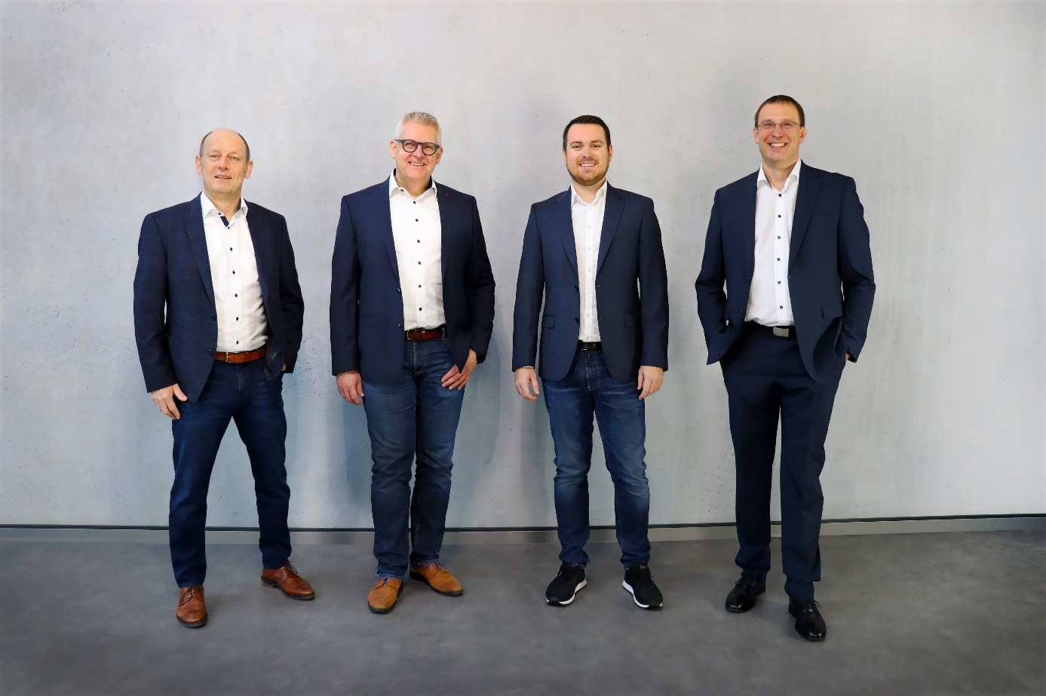
Management of the b-plus Group from left to right: Michael Sieg (Managing Director b-plus GmbH), Alexander Noack (Managing Director b-plus technologies GmbH), Marius Reuther (Managing Director b-plus automotive GmbH), Harald Bügel (Managing Director b-plus mobile control GmbH)

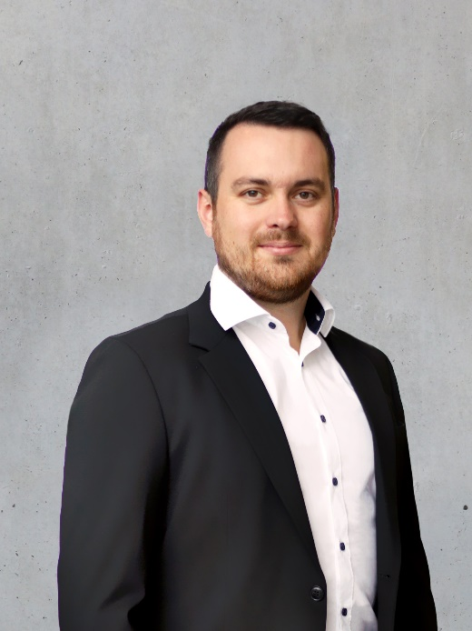
Caption: Marius Reuther, Managing Director of b-plus automotive GmbH
ANSPRECHPARTNER

Simone Adam
Marketing Communication
simone.adam@b-plus.com

Phone: +49 991 270302-0
b-plus.com

Address:
b-plus automotive GmbH
Ulrichsberger Str. 17
94469 Deggendorf
Germany

ABOUT B-PLUS GROUP
The b-plus Group employs around 240 people. It is an internationally networked development partner for the advancement of autonomous driving technologies, driver assistance systems and the automation of mobile machines. With its development tools, automotive software and mobile automation divisions, it offers its customers a wide range of measurement technology, software and hardware.

As a long-term partner, b-plus accompanies its customers from the identification of the problem to the implementation of the development solution and beyond. The teams at the Deggendorf, Regensburg, Cham and Lindau sites work closely together and hand in hand to offer comprehensive and holistic solutions.

