Deggendorf, February 24, 2022

b-plus launches with EDSwitch 10G a new addition for the AVETO Toolbox
Deggendorf, February 24, 2022 – With the high-performance switch EDSwitch 10G, b-plus presents a highly flexible element for compact data distribution of measurement data from test drives. The new Managed Ethernet Switch with PTP functionality complements the portfolio for efficient controlling, separation and bundling of data streams with a speed of up to 10 gigabits per second.

The new EDSwitch 10G is specially designed for compact test setups in the automotive environment to provide developers and engineers with a robust solution at a consistently high-quality standard. In addition to managing in-vehicle data streams, data can be distributed to ECUs as well as a recorder unit, and can also be managed across multiple Ethernet sources.

Designed for harsh environments
With an operating temperature range of -40 °C to +70 °C combined with a fanless design, the EDSwitch 10G is one of the most rugged IT switches on the market. The wide input voltage range from 9 V DC to 57 V DC makes it a reliable solution in the entire test, validation or verification process of measurement data.

Best data quality thanks to accurate time stamping
Based on a hardware implementation (IEEE1588v2 E2E Transparent Clock), time stamping accuracy of nanoseconds can be achieved in the network. This allows data packets from different sources to be correlated in time for further analysis and processing.

Distribution and separation of data streams at high data rates
High flexibility in data management is ensured on the EDSwitch 10G thanks to port mirroring as well as a virtual local area network (VLAN) configuration option. The port mirroring feature offers the possibility to mirror Ethernet data simultaneously to existing control devices as well as to a recorder unit such as b-plus BRICK2 or analysis platforms such as DATALynx ATX4.
VLAN configurations allow data flows from different Ethernet sources to be routed to the recorder unit via separate 10G upstream ports. This feature helps to save Ethernet ports on the recorder. The port mirroring feature can run in parallel to maintain data forwarding to existing ECUs.

EDSwitch 10G as part of the AVETO Toolbox
With the AVETO Toolbox, the b-plus Group presents a complete and integrated toolbox for the acquisition, analysis and processing of sensor data in the field of ADAS and autonomous driving. It offers a solution for the acquisition of sensor data during test drives and in-the-loop tests, such as HiL. The EDSwitch 10G is already integrated and tested in the AVTEO Toolbox. Furthermore, the EDSwitch 10G is compatible with the XTSS timing architecture of b-plus. Thus, it is pre-qualified for use in the automotive test area and functions optimally for the respective application.

The three product variants of the EDSwitch 10G with different port configurations are available now. For more information, please visit the EDSwitch 10G product page.

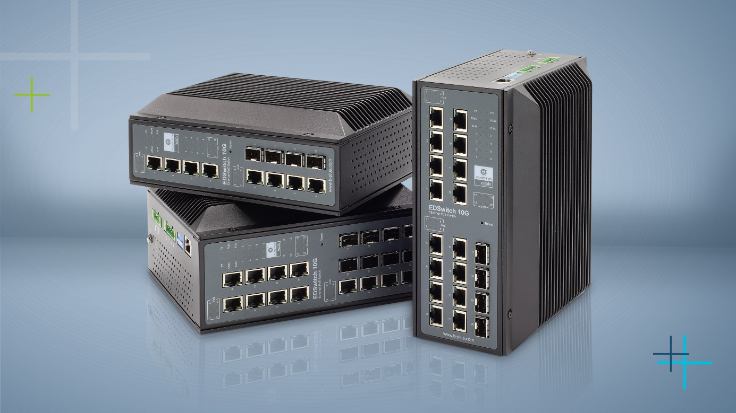Product picture: EDSwitch 10G Variants

Press contact
Simone Keil Marketing Communications
simone.keil@b-plus.com
Adrian Bertl Product Marketing
adrian.bertl@b-plus.com

Phone: +49 991 270302-0
www.b-plus.com

Address:
b-plus GmbH
Ulrichsberger Str. 17
94469 Deggendorf
Germany

About b-plus GmbH:
The b-plus Group is with more than 240 employees an international leading development partner for advancing technologies in the fields of autonomous driving, driver assistance systems and the automation of mobile machines. With its development tools, automotive software and mobile automation divisions, it offers its customers a wide range of measurement technology, software and hardware.

As a long-term partner, b-plus accompanies its customers from the identification of the problem to the implementation of the development solution and beyond. The teams at the Deggendorf, Regensburg and Lindau locations work hand in hand to provide comprehensive and holistic solutions.

