Deggendorf, April 01, 2022

b-plus launches “b-prepared” product vending machine
Deggendorf, April 1st, 2022 – b-plus is a pioneering new mobility and now also enables the time-independent availability of its products and more with the product vending machines "b-prepared". The product vending machines contain CAN modules, ISOBUS accessories and snacks such as crackers and smoked meat for the hunger in between.

True to the motto "Pioneering New Mobility", b-plus is expanding its sales channels and now offers vending machines in which b-plus products such as the b-CANCubeMini and b-ISOBUS AUX-N Gateway can be purchased directly. This enables agricultural technicians and farmers to quickly obtain expansion modules and spare parts for their agricultural machinery in the event of technical bottlenecks, regardless of the time of day and even on weekends.

Long breakdowns and downtimes of machines due to long delivery times are eliminated. The "b-prepared" vending machines are placed on busy country roads close to where they are used. This allows farmers to access the products quickly. Possible is this thanks to the robust design and integrated cooling.

Thanks to the cooling function, the vending machine can also offer snacks such as hard sausage and black smoked meats. These come from regional Bavarian butchers located in the area close to the headquarters of b-plus mobile control in Deggendorf.

Further flexibility is offered by the various payment methods. Currently, the payment methods cash, EC card and Paypal are offered. A direct connection to common online brokers for payment with Bitcoin is being worked on for the next generation.

"We are very proud to present "b-prepared" to our customers." Stefan Zellner, product manager at b-plus mobile control, is pleased. "We combine practical, quick remedy for product failures with a tasty snack for in between." The shopping experience is made possible next to the field.

The first product vending machines will be delivered on April 1 and tested in Cham, Deggendorf, Regensburg and Lindau, Lake Constance. If you are interested in "b-prepared" and our products, please visit our website and contact us for a personal exchange.

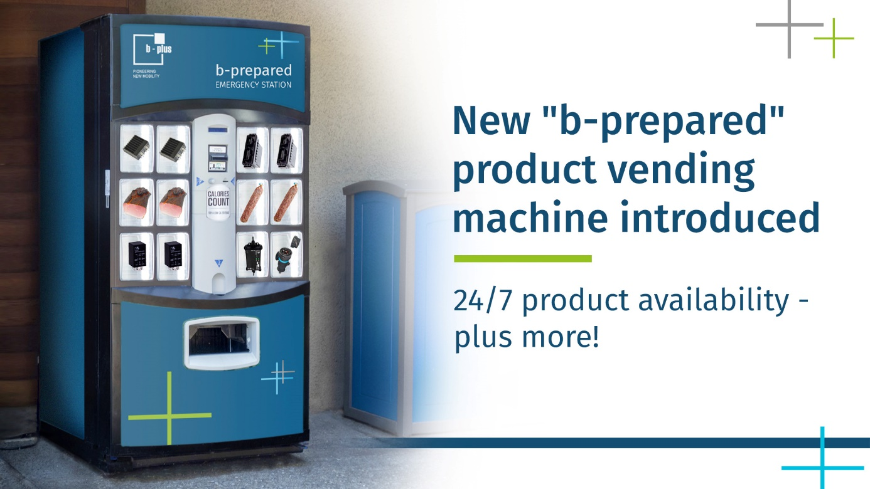Product picture: “b-prepared EDSwitch 10G Variants

Press contact
Simone Keil Marketing Communications
simone.keil@b-plus.com
Stefan Zellner Product Marketing
stefan.zellner@b-plus.com

Phone: +49 991 270302-0
www.b-plus.com

Address:
b-plus mobile control GmbH
Ulrichsberger Str. 17
94469 Deggendorf
Germany

About b-plus mobile control GmbH:
b-plus mobile control GmbH is a long-standing expert in the field of all mobile applications, from trucks to mobile machines. In addition to development services, it offers its own control hardware and proven control and display components from established manufacturers. It convinces through long-time industry knowledge and customer relationships, for which optimal automation solutions are developed.

