LOGifyer B1 SE: b-plus introduces compact data logger for ADAS and AD sensor data acquisition
System solution for synchronous recording of camera, radar and lidar data with reduced integration effort
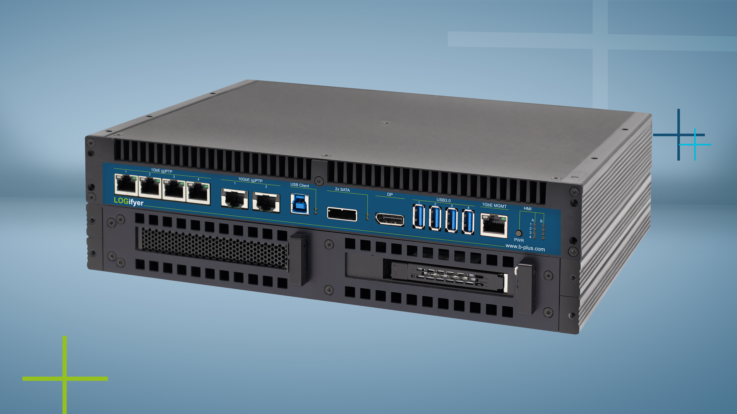
Deggendorf, August 06, 2026 – b-plus GmbH is expanding its portfolio of measurement and logging systems with the LOGifyer B1 SE. The entry-level data logger is designed for the synchronous acquisition and validation of camera, radar and lidar sensors.
The LOGifyer B1 SE follows a focused approach and provides a compact system platform for typical sensor setups. The device is equipped with four 10-Gigabit Ethernet ports and two additional 1-Gigabit ports, all of which are (g)PTP-capable and enable precise time synchronization between connected sensors. The system supports the use of removable storage media for efficient handling of large data volumes.
The software foundation is the proprietary LOGifyerOS, which enables immediate commissioning without additional system integration. In addition to the user interface, a virtualization environment is available that allows application-specific functions to be executed directly on the system.
The LOGifyer B1 SE is designed for use in demanding environmental conditions and ensures stable functionality under corresponding temperature and vibration loads.
With the new B1 SE version, the b-plus Group positions an entry-level solution within the LOGifyer product family, specifically addressing requirements where a balanced ratio of functionality, system complexity and cost is paramount.

Contact Person

Laura Kalka
Product Marketing Lead
laura.kalka@b-plus.com

Tel.: +49 991 270302-0
www.b-plus.com

Adress:
b-plus technologies GmbH
Ulrichsberger Str. 17
94469 Deggendorf
Germany

About the b-plus Group
The b-plus Group is a leading international development partner specializing in cutting-edge technologies for autonomous driving, driver assistance systems, and the automation of mobile machines.
With over 200 employees, the company specializes in powerful development tools, advanced automotive software, robust industrial solutions as well as mobile automation.
It offers customers a comprehensive range of measurement technology, software, and hardware.
As a trusted long-term partner, b-plus supports its clients from problem identification to the implementation of tailored development solutions and beyond.
Teams at its locations in Deggendorf and Regensburg work seamlessly together to deliver holistic, end-to-end solutions.

