Deggendorf, 03.02.2020

Server platform in the test vehicle

Get a reliable grip on Big Data with the next Car-Server generation from b-plus

For extremely computationally intensive applications such as the development of algorithms or artificial intelligence, b-plus implemented the 19-inch car server "DATALynx ATX4". A powerful b-plus automotive power supply combined with liquid cooled processors allow high-end CPU and graphics performance up to 60°C ambient temperature in the vehicle.
This platform allows the latest server CPU generations, such as AMD EPYC™ 2, 7002 and alternatively the 2nd generation Intel® Xeon® Scalable processors to be used in the vehicle. This is enabled by an extended liquid cooling system, in which heat dissipation can be significantly increased and the server can be operated in an operating temperature range of -10 to 60°C ambient temperature. At the same time, the liquid cooling reduces the mechanical stress on individual boards, as the heat sinks required for this are significantly more compact, thus achieving a significantly higher durability.
In terms of flexibility for adaptation to the respective test setup in the vehicle, DATALynx ATX4 offers extensive expansion possibilities.
Depending on the platform used, up to 7 PCIe 3.0 slots can be used for extensions such as up to 5 graphics cards via future add-ons. Due to the increased number of interfaces, the desire for a larger storage capacity directly on the device is also increasing, for which the system can accommodate up to 10 SATA SSDs.
Seamless integration into the vehicle is achieved through a completely vehicle-compatible robust design in conjunction with an automotive power supply with a supply voltage of 6-32V.
With this platform b-plus brings the data center and massive GPU power into the vehicle, as required for recording and processing of algorithms, image processing and neural networks.
The product will be presented for the first time at Embedded World 2020 and samples will be available from April 2020.

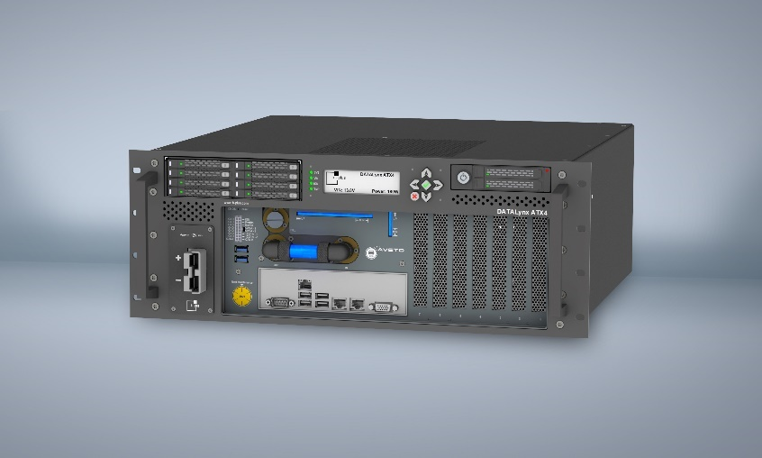
Image caption: DATALynx ATX4- Server und Computing Plattform der b-plus GmbH

Press contact:
Christine Schäfer christine.schaefer@b-plus.com
Robert Pletz robert.pletz@b-plus.com
Tel.: +49 991 270302-0

www.b-plus.com

Adress:
b-plus GmbH
Ulrichsberger Str. 17
94469 Deggendorf
Germany

About b-plus GmbH:
With more than 220 employees at the locations Deggendorf, Regensburg and Lindau (as of December 2019), b-plus GmbH is a medium-sized, internationally leading technology company in the automotive industry and in the field of automation of mobile machines.
It supports its global customers with software and hardware solutions, among others for applications such as automated and autonomous driving, and in the field of vehicle sensor technology.
b-plus GmbH is a pioneer, technology driver and engineering partner for the development, testing and validation of ECUs and driver assistance systems.
In 2019 it was awarded the renowned prize "Bavaria's Best 50" by the Bavarian State Ministry of Economic Affairs, Regional Development and Energy as one of the 50 fastest growing owner-managed medium-sized companies in Bavaria.

