Deggendorf, 03.02.2020

Data Lake for test vehicles

One storage for all vehicle loggers

In order to meet the rapidly increasing requirements for recording and storing large amounts of data in a test vehicle, b-plus offers MDLake, a novel solution. This storage unit based on network technology enables a high transfer rate of up to 128Gbit/s and a capacity of up to 240 TByte.

A data lake describes a storage solution for Big Data, consisting of a large amount of raw data. Due to the increasing data transfer rates for automotive applications, triggered by the increasingly high-resolution sensors, a conventional data storage units can no longer meet the requirements in the vehicle. For future-oriented storage solutions, bandwidths and capacities are required that are commonly known from data centers with server technology. For this reason, b-plus developed its own, new benchmark-setting solution, the mobile data lake "MDLake". An extremely powerful storage for applications in test vehicles, which allows the storage of large data volumes, up to 240TByte, from up to eight different data sources.

The robust, vehicle-suitable MDLake of the b-plus enables mobile SAN applications (Storage Area Network) in the ADAS/AD area. SAN describes a data storage network in which one or more data sources and sinks can be present. The memory is completely independent of the operating system of the respective vehicle logger. Based on the RDMA technology from the server segment RoCE v2 combined with correspondingly optimized transmission protocols (NVMe-oF), MDLake enables transmission rates of 80Gbit/s from one source and up to 2x 64Gbit/s with multiple sources. With this new class of devices, a new milestone for measurement architecture in vehicles has been set in the automotive segment.

MDLake offers the developer of a sensor, a measurement technology manager or a research engineer the possibility to connect built-in recorders and data loggers in the test vehicle via 2x100Gbit/s QSFP28 interfaces. These interfaces can be used simultaneously by up to 8 devices and offer a cumulative recording speed of 128Gbit/s. Furthermore, the use of a 6-32V automotive power supply guarantees the trouble-free operation of the memory in the vehicle.

MDLake will be launched at the Embedded World 2020 and samples for the evaluation of this new device class will be available in April 2020.

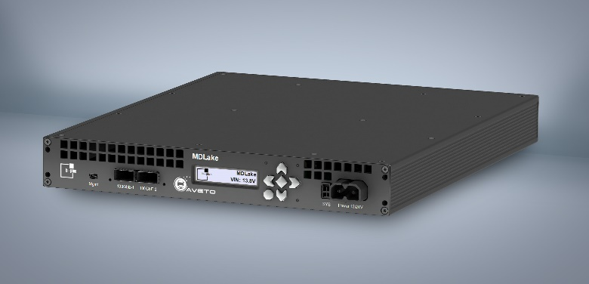
Image Caption: MDLake - Data Center SAN solution for test vehicles

Press contact:
Christine Schäfer christine.schaefer@b-plus.com
Robert Pletz robert.pletz@b-plus.com
Tel.: +49 991 270302-0
www.b-plus.com

Adress:
b-plus GmbH
Ulrichsberger Str. 17
94469 Deggendorf
Germany

About b-plus GmbH:

With more than 220 employees at the locations Deggendorf, Regensburg and Lindau (as of December 2019), b-plus GmbH is a medium-sized, internationally leading technology company in the automotive industry and in the field of automation of mobile machines.
It supports its global customers with software and hardware solutions, among others for applications such as automated and autonomous driving, and in the field of vehicle sensor technology.
b-plus GmbH is a pioneer, technology driver and engineering partner for the development, testing and validation of ECUs and driver assistance systems.
In 2019 it was awarded the renowned prize "Bavaria's Best 50" by the Bavarian State Ministry of Economic Affairs, Regional Development and Energy as one of the 50 fastest growing owner-managed medium-sized companies in Bavaria.

